
Section 1

Facilitation Guide

(Digital version of guide on WHERE WILL YOUR AGENCY STORE THIS)

Purpose: (What is the purpose of the meeting?)

Context: (How does this meeting fit the goals of the unit/organization? Is this a stand-alone meeting? Part of a larger effort? Has this group met on this topic before?)

Topic(s)

: (What will be covered in the meeting? Note: this is not the agenda, but will be used to build an agenda)

Out of scope (or sideboards): (What is outside the intent of the meeting; or what are the limits that the group should not exceed?)

Goal(s): (What will success look like?)

Objectives: (What are the measurable outcomes from this meeting?)

Potential issues: (Are there any sensitive topics or hot button items to be aware of?)

Decision-making process: (How will decisions be made? Consensus, majority, decide and report, decide and recommend, etc.)

Deliverable(s): (What, if any, products are expected to come out of the meeting, and who is responsible for them?)

Participation: (List the names and roles of meeting participants)
Leader:
Facilitator:
Recorder:
Participants:

Stakeholders:
(Who might be impacted by what comes out of the meeting?)

Preparation: (What needs to happen before the meeting? Who will be responsible?)

Follow-up Responsibilities: (Is any follow-up expected, and if so, who is responsible? What is the timeline?)

Logistics: (Room size & arrangement, supplies, equipment, refreshments/meals; who is responsible?)

Section 2

Meeting Checklist
Setting Up
Determine meeting purpose. | Identify potential problems that could arise and strategies to handle them
Write down desired outcomes for the  meeting | Send meeting announcement with agenda to attendees
Design agenda
Equipment/Supplies Checklist
Easels | Colored dots
Chart paper | 3”x5” Post-it Notes
Markers (black, brown, green, red, blue) | HDMI Cable
During the Meeting
Get agreement on desired outcomes | Summarize what has happened  periodically during the meeting
Clarify decision-making method | Suggest a process or tool when  needed
Clarify/explain any constraints that  may limit solutions | Protect others from personal attack
Encourage participation | Keep the meeting on track; start on time and end on time
Set up “Parking Lot” chart
Follow Through
Prepare and distribute minutes,  including agreements made and  actions to be taken |  | Follow through on action items
Make sure unresolved issues get  addressed |  | Revisit Parking Lot and determine course of action

Section 3

Icebreakers
Would you Rather? | Have all meeting participants answer the same or different questions, depending on preference, as part of their introduction. | Examples:  - Would you rather only have summer or winter for the rest of your life?  - Would you rather go on a hike or see a movie?
18 & under | Ask each participant to share one accomplishment they had before they turned 18.
Two Truths and Lie | Each participants shares three “facts,” two that are true and one that is a lie. The group then determines which is the lie. | Considerations:  - Size of the group  - Time allowed for ice breakers (this could take a while)
Fun Questions | Have all meeting participants answer the same question as part of their introduction. | Examples:  - If you could be any animal, what would you be and why?  - If you could have any celebrity over for dinner, who would it be and why?  - Is it soda, pop, or coke?  - If you could instantly become an expert in something, which skill would you choose?
Who is it? | Have everyone write a fun or interesting fact that no one else knows. Facilitator collects the facts and reads them out loud. Participants guess whose fact it is. | Considerations:  - Size of the group  - Time allowed for ice breakers (this could take a while)
Bucket List | Have participants share one thing on their bucket list. This could be a place to visit or something they want to achieve.
Icebreaker Thumb ball | Have participants stand up and throw the thumb ball around the room. As participants catch the ball, have them answer the question under their right or left thumb (whichever you chose). | Considerations:  - Size of the group  - Time allowed for ice breakers (this could take a while)

Section 4

Generating Ideas- Brainstorming
What it is | Brainstorming is a technique for getting bigger and better ideas, and for putting a full range of ideas on the table before people take positions.
When to use | Use brainstorming when you want to 1) generate a free flow of creative ideas that are not bound by the usual barriers, 2) get everyone involved, and 3) generate a wide variety of ideas.
Duration | This process can take anywhere from 5 to 45 minutes, depending on the time available and how in depth you want to go.
How it Works  Basic Rules | The basic rules for brainstorming are simple:  - Let ideas flow freely -No evaluating until later  - There are no bad ideas -No debating  - Everyone participates - Build on the ideas of other  - Be creative -Think in new ways  - Keep it moving  - State the purpose and topic around which the group will be brainstorming, and make sure everyone is an agreement and understands the topic and the purpose. For example, are you brainstorming challenges or solutions?  - Explain to the group the rules of brainstorming and the process they will use. Give the group about 5 minutes to silently jot down ideas.
Unstructured | Unstructured – participants offer ideas as they come to mind.  - Open the brainstorming session once participants have had a few minutes to jot down ideas.  - Record ideas on chart paper as they are generated. Do not discuss or elaborate but do make sure you accurately captured the idea. Keep it moving.  - When people have run out of ideas, allow for a few minutes of thinking time and reflection. Sometimes the best ideas emerge when participants get their “second wind.”  - When there are no further suggestions, go back and clarify each suggestion so the meaning is clear to everyone. Combine similar ideas that are simply worded differently, but only if the ideas are nearly identical. Subtle differences are often important.  - If the goal is to identify the top ideas, use dot voting to identify three to five ideas participants think are best. Rule of thumb for the number of dots is number of participants divided by 3 (n/3).
Structured  Nominal Group Technique | Structured – participants offer ideas one at a time  - Explain that you will be calling on each person in the group, one at a time, and that you want them to offer one idea each time they are called on. If you call on a person that has run out of ideas, instruct them to pass.  - You will continue around the group until there are no additional ideas.  - Record ideas on a chart as they are generated. Do not discuss or elaborate but do make sure you accurately captured the idea. Keep it moving.  - When people have run out of ideas, allow for a few minutes of thinking time and reflection. Sometimes the best ideas emerge when participants get their “second wind.”  - When there are no further suggestions, go back and clarify each suggestion so the meaning is clear to everyone. Combine similar ideas that are simply worded differently, but only if the ideas are nearly identical. Subtle differences are often important.
Structured Silent Brainstorming | In this method, participants brainstorm silently, writing their ideas on post-it notes, one idea per post-it.  - Explain that participants will be writing their ideas on post-it notes.  - Explain that the ideas should be specific yet concise. Discourage them from writing a paragraph.  - Encourage them to write legibly and to use Sharpies, if provided; ink does not show up well and is not easy to read from any distance.  - Hand out post-it notes and sharpies.  - Have participants write one thought/idea per post-it. This is done silently; make sure everyone is participating  - Give the group about 15 minutes to write down ideas.  - If the topic is sensitive, the facilitator can gather the post-it notes and read them (while recording them on chart paper or wall).  - If the topic is not sensitive, have one person in the group read one of their ideas and put it on chart paper. Ask if others have similar ideas, and group them with the first idea. Have the person read their next idea, and so on until they have posted all their ideas. Move to the next person in the group and continue until everyone’s ideas are presented.  - When there are no further suggestions, go back and clarify each so the meaning is clear to everyone. Combine similar ideas that are simply worded differently, but only if the ideas are nearly identical. Subtle differences are often important.
Carousel Brainstorming | - Put sheets of chart paper on the walls around the room, about 1 sheet for every 8-10 participants, or with a small group, 1 sheet for every 3-5 people.  - Divide into groups and have each group go to one of the posted sheets of paper.  - Pose the question or topic for brainstorming (different question/topic on each chart paper) and have each group spend 5 minutes writing down their ideas on the paper.  - At the end of 5 minutes, have each group rotate to the next paper to the right. Give them 5 minutes to read the ideas and add to them.  - Continue to rotate until no new ideas are being added.  - It will take some time to combine all the lists, so this works well for capturing the ideas but not for winnowing them at the same meeting.

Facilitator Tips for Brainstorming
DO | DON’T
Do keep things moving at a fast clip. | Don’t interrupt.
Do encourage people to take turns. | Don’t say “We’ve already got that one.”
Do give silly ideas the same treatment as serious ones. | Don’t say “Ooh, good one!”
Do move around to keep the energy level up. | Don’t say “Are you sure you want me to write that one down?”
Do say if a person is difficult to follow, “Let’s see if I’ve got it right so far.” | Don’t favor the “best” thinkers.
Do repeat the purpose often: “Who else has an idea about this?” | Don’t use frowns, raised eyebrows, smiles or other nonverbal gestures that signal approval or disapproval.
Do give a warning when the end is approaching. | Don’t give up the first time the group seems stuck.
Do consider asking someone to record ideas. | Don’t simultaneously be the leader, facilitator, and recorder.
Do expect a second wind of creative ideas after the obvious ones are exhausted. | Don’t rush or pressure the group. Silence usually means that people are thinking.

Narrowing Techniques- Affinitizing
What it is | Affinitizing is a way of grouping ideas to begin narrowing from lots of ideas to actionable items.
When to use | Use after brainstorming to identify key ideas for follow-up.
Duration | 30-45 minutes
How it Works | Affinitizing is a step in the Lean idea generation process. An affinity group is a group of ideas that have a common interest or goal or acting together for a specific purpose.  It works best if brainstorming has been done using post-it notes and in small groups of 4-5.  - Have each person share their ideas with the small group.  - Have the group organize their ideas into categories. Label the categories with a header.  - One way to do this is to have one group member place their first post-it notes on chart paper and describe it, then other members post related post-it note ideas near that one and describe how they relate  - Repeat these steps until the first member is out of post-it note ideas then move to another team member, and so on, until all ideas have been shared and put into a group.  - Label each category with a header.  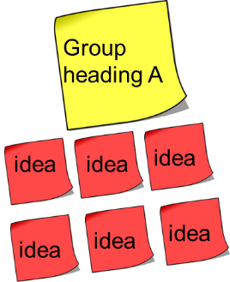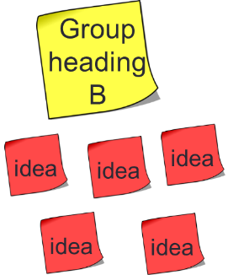

Discovery- 5 Whys
What they are | A visual tool used to help a team identify and explore all possible causes related to a problem, issue, or situation to discover its root cause(s).
When to use | Once a team has defined a problem and is seeking to identify cause.
Duration | 15-30 minutes
How it  Works | Use the 5 Whys to drill deeper into a symptom or potential cause identified in the fishbone diagram or other process.  - Begin with the symptom or potential cause and keep asking why until you get to the end of a chain.  - It might take only 3, or more than 10, to get to the end.  - Once the group has reached the end of the chain, identify potential solutions to be tested.  Example: A person notices they have been gaining weight, and they have determined than one reason might be the fact they are grabbing fast food on the way home from work 3-4 nights a week.  Why am I eating fast food 3-4 times a week? A: Because I am really hungry.  Why am I really hungry? Because I miss lunch.  Why do I miss lunch? Because I get busy and don’t have time to go out.  Why do I have to go out for lunch? Because I don’t pack a lunch.  Why don’t I pack a lunch? Because I don’t have anything at home to bring.  Potential solutions:  - Buy easy things to pack for lunch.  - Pack lunch the night before.  - Keep some frozen or canned food at the office.

Analyzing- Force Field Analysis
What it is | A process to look at the positives and negatives of a situation/issue/problem side-by-side so they are easily compared.
When to use | When you want to identify positives to reinforce or identify negatives to reduce or eliminate in each situation; when you want to make sure you have considered all impacts of a potential solution to an issue.
Duration | 30 to 45 minutes
How it Works | - At the top of the chart paper, write the issue/problem/situation you plan to analyze.  - To the right of that, write a description of the ideal situation you would like to achieve.  - Below that, draw a large letter T, dividing the easel paper in half vertically.  - Label the left column “driving forces” and the right column “restraining forces.”  - Brainstorm the forces that are driving you toward the ideal situation, internal or external, and list them in the left column.  - Brainstorm the forces that are restraining movement toward the ideal state, and list them on the right side.  - Determine which driving forces would, if strengthened, move you closer to the ideal state.  - Determine which of the restraining forces would, if reduced or removed, allow the most movement toward the ideal state.  - Use dot voting if you want to rank the actions.  Note: It is often more effective to identify barriers to remove than to double down on pushing positive factors for change.  Issue: Ideal state:  Driving forces (+) Restraining forces (-)

Analyzing- SWOT

Strengths, Weaknesses, Opportunities, and Threats
What it is | SWOT is a strategic planning tool that also works well to identify improvements in a process. It is a high-level look at the situation under consideration: what is working well; what could be working better; what are opportunities for improvement and barriers to moving forward. Strengths and weaknesses are internal to a process; opportunities and threats are external.
When to use | Use at or near the beginning of a problem-identification process to help identify the issues, challenges, or ideas on which to focus.
Duration | This process can take anywhere from 20 minutes to an hour, depending on the time available and how in depth you want to go.
How it Works | - Prepare chart paper with a vertical line down the center. Write the headings “Strengths” on the left and “Weaknesses” on the right. Prepare a second sheet with the headings “Opportunities” and “Threats.”  - Explain to the group the process or situation to which they will be applying SWOT. Tell them they will be brainstorming within each category for a certain period of time (e.g., 5 or 10 minutes). Do one category at a time, capturing statements in the appropriate columns on the chart paper.  - Strengths – Identify the current strengths of the existing process or situation: what is good about it; what is going well.  - Weaknesses – Identify the current weaknesses of the existing process: what isn’t working or missing.  - Opportunities – Identify the external conditions that are helpful in achieving the objective under discussion. Examples may include better access to information; potential to coordinate with another section or entity doing similar work; availability of new technology; a change in the expectations of the customer; or new rules.  - Threats – Identify external showstoppers that could block your ability to achieve the scope of work, goals, and objectives of the process under discussion. For example, sections aren't sharing information in the most expedient way, so decisions are made without the right tools, or customers don't have access to the most recent tools needed to supply information needed by the agency correctly the first time.  - Ask the group what they see. You may see similarities between strengths and weaknesses, such as, our group communicates well with each other, but not with the other sections. You may also find that threats often offer opportunities.  - The information gathered can be used to determine strengths to build on, opportunities to take advantage of weaknesses to improve, and/or threats to mitigate. The specific use will depend on the context in which the SWOT is conducted.

Prioritizing- Dot Voting
Dot Voting
What it is | Also called multi-voting, participants use dots to indicate their highest priorities in a list of options or actions.
When to use | Use this when you have a list you want it narrowed down to the items of most interest to the group or when you want to identify the top 3-5 items in a list. This is often used after brainstorming to narrow a long list; as part of a fishbone diagram to identify one or two things to work on; after a force field analysis to choose driving or restraining forces to pursue; etc.
Duration | 5-10 minutes
How it Works | - Use N/3 to determine how many dots to give each person, where N = number of participants. Divide that by three and give each participant that many “votes.” Use dots if you have them. If dots are not available, people can use a marker to draw a dot.  - Instruct participants to place their “votes” on what they think is most important. They can place all their dots on one item or spread them over several. However, they cannot place fractions of dots.  - Once the group is finished, tally the marks and review with the group to see if they are comfortable with the outcome.

Assessing Priorities- Impact/Difficulty Matrix
What it is | The Impact/Difficulty matrix is a tool to assess the relative priority and “actionability” of ideas. Rather than ranking ideas from 1 to 5, the Impact/Difficulty matrix helps to group ideas into those that will have a high impact and be relatively easy to implement, those with low impact and easy to implement, and so on.
When to use | Use the Impact/Difficulty matrix to identify which ideas have the highest impact and can be easily implemented.
Duration | From 45-90 minutes, depending on the number of ideas.
How it Works | - Starting with a numbered list of items, create a small post-it note for each item number (e.g., A1, B5, C3, etc.).  - Draw a quad chart on paper and label as illustrated below.  - Have the group determine the criteria for impact and difficulty. Impact may relate to the amount of time an idea would save in a process, the number of people that would benefit, etc. Difficulty might be defined by time needed to implement, whether policy change would be needed; whether the team has control over implementation; etc.  - Ideas in:  - Quadrant I (upper left) are high impact and low difficulty; these are the actions to focus on.  - Quadrant II (lower left) are low impact and low difficulty. They can be “just do it” actions.  - Quadrant III (upper right) have a high impact but are difficult to implement. They may or may not be included in an action plan and should be captured as longer-term recommendations.  - Quadrant IV (lower right) have low impact and high difficulty. These will be the lowest priority and may or may not be included in an action plan or recommendations. The ideas will be saved and may become more feasible/higher impact as circumstances change.  - If the group is small enough, have the participants do the placing. If it is a large group, either have the facilitator place the ideas at the direction of the group or have a sub-set of the group place the ideas. After completion, ask the group if any MAJOR changes are needed.  - Have the group discuss each item and place it in one of the four quadrants. They must all agree to where an action is placed on the matrix. The group has the final say on placement, rather than the facilitator.  - Take a photograph of the matrix for reference.

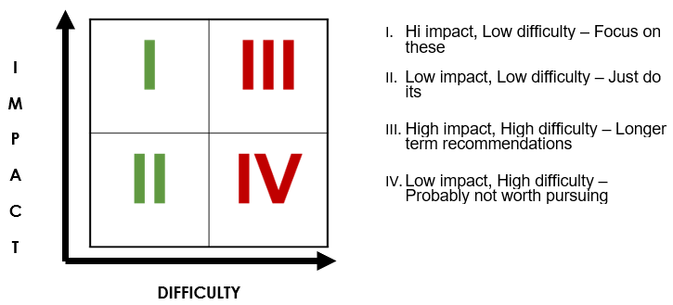

Section 5

Charting Tips
- Pre-write notes:
- If there is information you can prepare ahead of time it will save you time during facilitation and be less of a distraction.

- Test your markers:
- Make sure you have markers that work well.

- Use dark-colored markers:
- The contrast between dark ink and paper will make it easier to read. One suggestion is to use dark colors for graphs and bold colors to fill in information.
- Alternate between two colors when documenting lists. It will make them easier to read. However, avoid using red and green together as they are indistinguishable for people who are color blind.

- Print large enough for all to see (KILL – Keep It Large and Legible):
- Try to print when recording information. Make your letters about 2” in size with the same amount of space between lines.

- Record main thoughts/key input:
- Write an idea on the chart paper while it is being said. Check with the person providing the information to ensure you captured it correctly.

- Post the results:
- Post chart paper pages in sight for the team to reference, as needed.

- Capture ideas fully:
- Check with participants to make sure you capture their ideas correctly/fully.

- Don’t worry about spelling:
- Spell to the best of your ability and correct spelling when typing document information after the meeting.

- Avoid repetitive input:
- If the idea being stated is like one already captured, verify how the new idea might be different.

- Touch/Turn/Talk:
- Stand beside the chart, touch the bullet point you are about to talk about, then talk. Always face your audience while you speak.

- Capture ideas in a Parking Lot:
- When topics do not relate to the chart and you don’t want to lose the question or comment, you can capture it in a Parking Lot to come back to later or to ask the sponsor about.

Section 6

Managing Team Huddles

Before the Meeting
- Determine the purpose of the huddles (i.e., communication on specific topics, project status updates) and the frequency.
- Strive for consistency of time/day. Best when huddles are near the start of the day.
- Establish clear expectations for group participation ahead of time.
  - Is everyone expected to speak? Or only those with an update?
  - Does every project need to be reported on at every huddle?
- Prepare topics for huddles in advance, if necessary

During the Meeting
- Manage the order of participation. Establish the team expectations (i.e., the team leader will also say who is talking next, its always alphabetical, or participants “pass” the time to speak to others on the team.
- Make sure only one person speaks at a time.
- Don’t problem solve. Focus on identifying problems and schedule meetings outside of huddles to problem solve.
- End all huddles with action item recap.
- Try to keep things on topic. If someone goes off topic, you can nicely bring it back and say, “Let’s move on but we can talk more about this topic off-line.”
- Use a shared document so all team members can see discussions/topics discussed, even if they are unable to attend the huddle.
- Make sure to designate a notetaker when using the shared document, or a have all team members type their updates in.

Section 7

Common Facilitator Mistakes
One person dominates the discussion | Trying to control the person: “Excuse me Mr. A, do you mind if I let someone else take a turn?”  “Excuse me, Mr. A, you are taking up a lot of the group’s time.” | Focus on the other participants and encourage their participation.  Use the nominal group technique  Help the dominant person feel heard by capturing their ideas and/or creating a “parking lot” of items to discuss at another time.
Goofing around during discussion | Trying to organize people and getting into a power struggle | Aim for a break as soon as possible. Participants are likely worn out or overloaded. After a break they will be better able to focus.
Low participation by the entire group | Don’t assume that silence means consent. People may feel uncomfortable speaking up in a large group or with certain people in the room. | Switch facilitation techniques. For example, switch from a large group open discussion to a format that lowers the anxiety level such as idea-listing or small group activities.
Two people locking horns | Don’t try to resolve a conflict between two people who have no intention of reaching agreement. | Draw from the rest of the group. Ask, “Who else has an opinion on this issue?’ or “Let’s step back for a minute – are there other issues that need to be discussed?” Focus on the silent majority instead of on the dominant minority.
One or two silent members in a group whose other members actively participate | “Ms. Jones, you haven’t talked much today. Is there anything you’d like to add?” This puts the quiet person on the spot and may cause them to further withdraw. | “I’d like to get opinions from those who haven’t talked for a while.”  Make sure you’ve given time for everyone to think before asking them to speak. Introverts need time to process their ideas before offering them. Extroverts often start in right away; not giving introverts their think time. Breaking into small groups also works well. Small groups allow more people to have an opportunity to participate.
Whispering and side jokes | Ignoring the behavior in the hope it will go away. | Physically move toward people having a side conversation. They will often stop.  If it persists, it may be time for a break. Or maybe everyone needs time for a small group discussion.

Section 8

Shared Document Spaces
CHANGE CONTENT BASED ON YOUR AGENCY TECHNOLOGY.

How to create a shared document space
Step One: Open the online version of the application you need (i.e., Word, Excel)
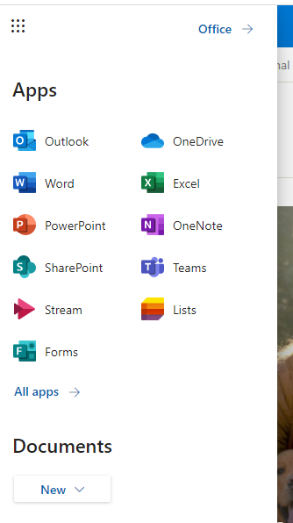
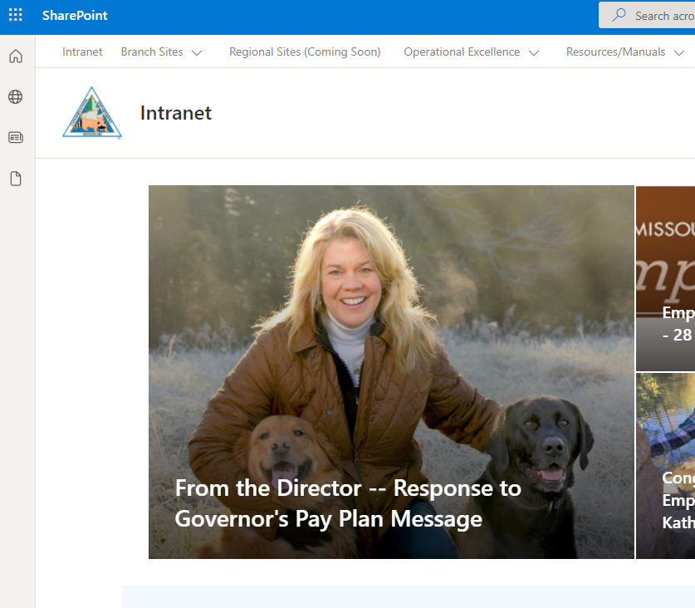

Step Two: Create a blank document. This document will be saved to your One Drive folder.

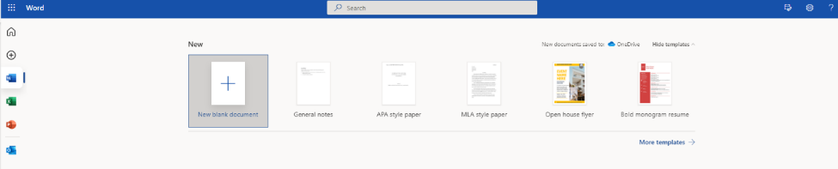

Step Three: Rename the document to the appropriate title.

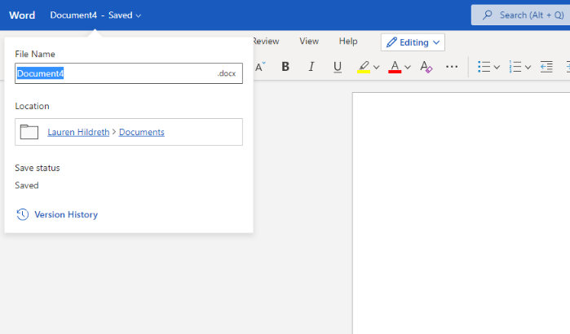
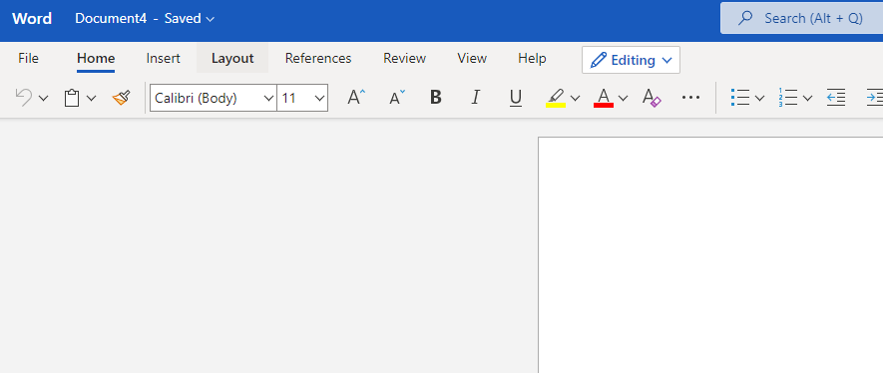

Step Four: Share the document with your team. Type the names in the search bar. This pulls information from outlook.
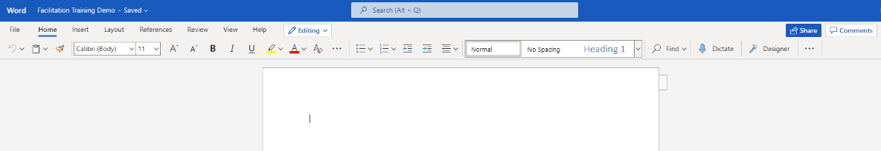

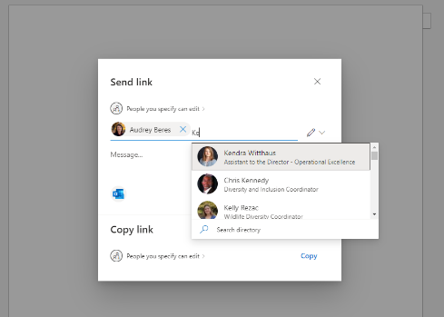

Tips:
- When collaborating on the same document simultaneously, ensure there is coordination on who types where. For example, if you are collecting ideas in a brainstorm- create a table and have participants select a line to type in. All participants can see the cursor of others in the document.
- Be mindful of cursor management. It can be tough to type with multiple cursors of different colors following your typing.
- Once you have determined where the document should be stored, move it. Collaboration pages, like those for the branches, are great places to put project-based information. See below for granting access to non-branch team members.

Granting Access to Collaboration Folders
Step One: Open collaboration location.
Step Two: Determine what folder, or folders, need to be shared. Only grant access to specific folders.
Step Three: Click the three dots to see the sharing option.
